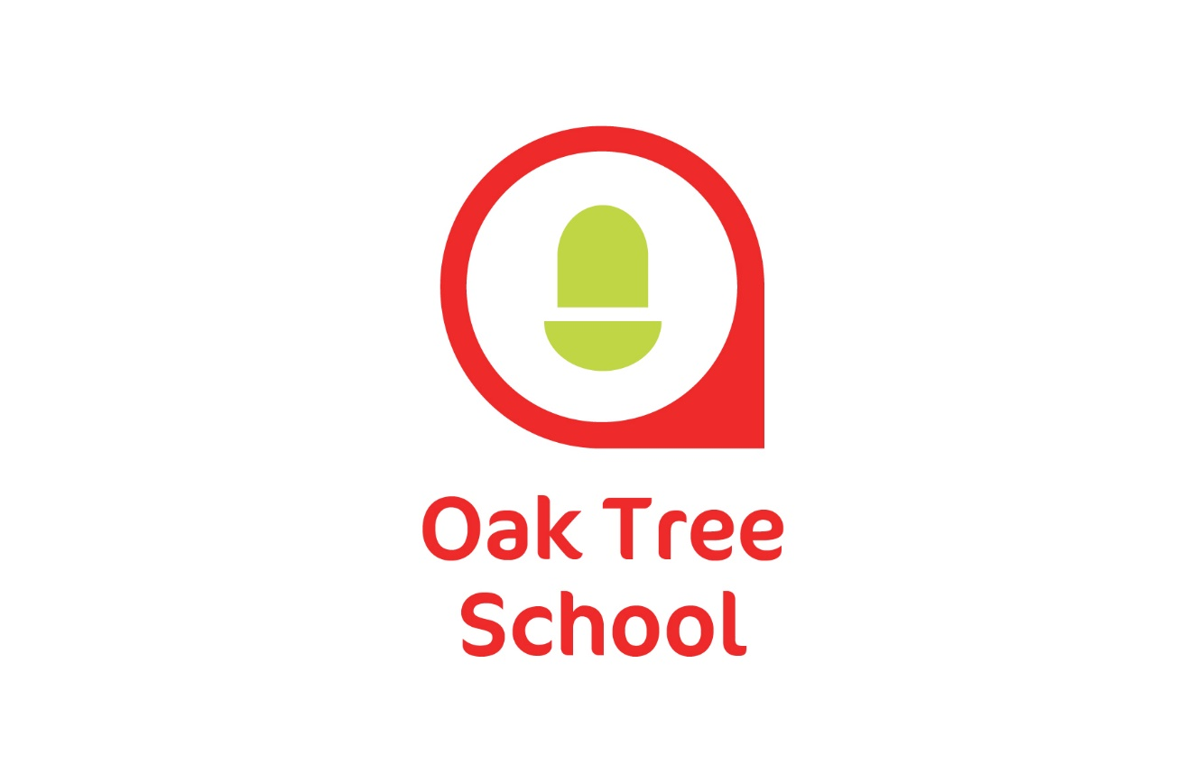

Careers Education and Guidance Policy

|  |  |
| --- | --- |
| **Policy Version** | **V4** |
| **Review Date** | **December 2023** |
| **Owner** | **Chris Penfold & Ben Gregor – Careers Leaders** |

**Document History**

|  |  |  |  |
| --- | --- | --- | --- |
| **Version** | **Comments/Amendments** | **Name** | **Review Date** |
| V1 | Policy Created | Kevin Jackson | July 2019 |
| V2 | No amendments | Kevin Jackson | October 2021 |
| V3 | No amendments | Kevin Jackson | July 2021 |
| V4 | Title, main sub headings and adapted content. Detailed programme details removed. | Chris Penfold & Ben Gregor | December 2022 |
|  |  |  |  |
|  |  |  |  |
|  |  |  |  |

**Vision & Values:**

This policy is underpinned by our one simple vision that at Oak Tree School we aim to deliver the best education for every child that attends. Careers provision is a pivotal part of our curriculum from years 7 to 11, and as a result we are committed to delivering a careers programme to prepare our learners for adulthood and transition to post 16 education or training when they leave Oak Tree School. We aim to achieve these goals by:

1. **To develop enterprise and employment skills**

Every child who attends Oak Tree School will have the opportunity to develop skills that will support their transition to post 16 education and/or employment through the linking of curriculum to careers encounters with employers and employees and experiences of work places. Oak Tree School also work collaboratively with external providers such as local colleges and independent organisations which offer children the opportunity to develop these skills outside of the school environment. Oak Tree School will also support children through an outreach programme should this be appropriate and necessary for their personal and social development skills. Employability skills will be embedded within core and vocational subjects, including PSHE, and be supported with the introduction of discrete lessons in KS4, focussing on developing skills for employment and progression through a blend of accredited and non-accredited learning.

1. **To encourage participation in further learning and / or employment**

Oak Tree School will do this through careers fayres, skills events and open events that are held by local post 16 providers of education and training that are included in the Cornwall SEND Local Offer. Oak Tree School will work alongside these providers to support children in to post 16 education and training through open days, taster days and transitional visits. Children and their parents will also be provided with independent personal guidance through CSW who hold the transitions contract with Cornwall Local Authority for supporting transitions for young people with SEND. CSW will work closely with the school to ensure that children will have a personalised progression plan linked to their future aspirations.

1. **Meet the needs of every child and focus on their future aspirations**

Oak Tree School will ensure that they will embed all eight of the Gatsby standards as set out in the Education Act 2017. From KS3 children will have a planned annual careers plan that will provide them with knowledge and skills to make informed choices about their future. This will include at least one careers interview with a CSW advisor who will offer independent advice and guidance. The careers programme will be differentiated based on the child’s individual needs and aspirations ensuring that they are equipped with the skills and knowledge to confidently make realistic and ambitious choices about their future.

1. **Involve parents and carers**

At Oak Tree School we aim to provide our children with the skills, knowledge and information that will enable them to make their own choices regarding their future, however we recognise parents and carers as co-partners in the career development of their child. We will support parents gain confidence and capability to support their child’s planning and decision-making through newsletters, school website, careers events and EHCP annual reviews. Parents and carers will be informed and kept up to date regarding any planned work experience placements, college or training provider visits and / or taster days, transition visits and all other training or employment opportunities.

**Statutory Requirements & Expectations**

Oak Tree School is committed to fulfilling its statutory duties in developed by the Department for Education, which references Section 42A and 45A of the Education Act 1997. This states that the range of delivery is delivered under the Gatsby Benchmark framework. The SEND Code of Practice which provides statutory guidance on duties, policies and procedures relating to Part 3 of the Children and Families Act 2014 states that pupils from year 8 to year 13 are provided with independent careers guidance and the “Baker Clause” introduced as an amendment to the Technical and Further Education Act 2017 that stipulates that schools must allow colleges and training providers access to every student in years 8-13 to discuss non-academic routes such as apprenticeships or T-Levels.

**Learner Entitlement**

Every student at Oak Tree School is entitled to high quality careers education and guidance as part of their overall education package.

All pupils can expect to:

* Understand yourself, your interests, skills, behaviours, strengths, areas of development, likes and dislikes, and how this affects the choices that you make.
* Find out about different courses, what qualifications you may need and what opportunities there may be for you.
* Provide you with the skills and knowledge to empower you to make informed choices about your future careers aspiration by exploring regional labour market trends.
* Have encounters with employers and employees within your chosen curriculum area and intended career path and gain experiences of workplaces through work placements, workplace visits or job shadowing.
* Develop skills and behaviours that you will need for further academic studies and employment.
* Be supported to make realistic, but ambitious choices about future courses and potential jobs.
* Develop a personal action plan that will help you plan for your future pathways.
* Understand the options available to you when you leave Oak Tree School after year 11. This may include further education courses, training and employment including supported internships, apprenticeships and T-Levels. This will include at least one careers interview with a CSW advisor who will offer you independent advice and guidance as well as visits and / or taster sessions at potential post 16 education or training providers.
* Be able to make effective applications for jobs, further education courses or training.
* Develop your interview skills.
* Develop your digital literacy skills.

**Management & Delivery**

Oak Tree School recognise the importance of putting in place effective arrangements for the management and delivery of the careers programme.

Oak Tree School have two designated Career Leads who along with the Senior Leadership team monitor the quality of the careers programme. This includes ensuring that the careers curriculum meets the standards set out within the Gatsby Benchmarks using the Compass careers benchmark tool for special schools, identify priorities to inform quality improvement plans, and work closely with external professional stakeholders such as Cornwall Local Authority, outreach and post 16 education and training providers. Careers Leads will also be responsible for working directly in partnership with CSW who will provide children with independent personal advice and guidance.

Careers Leads and Senior Leadership team will support Heads of Faculty and teachers embed this policy within their curriculum areas, inform school employees of the policy as well as their role in its implementation. New staff will be given notice of this policy upon induction to Oak Tree School.

Oak Tree School work closely with external stakeholders through the delivery of alternative offsite provision as well as encounters with employers including external work placements. Careers Leads will be responsible for completing statutory checks on each of these providers prior to a child beginning their placement with them.

**Stakeholders & Partners**

Oak Tree School recognise that parents and carers play an important role in their child’s careers development. Parents and carers will be supported in making informed decisions to aid their child plan for future education and employment aspirations. This will be achieved as outlined in the “Vision and Values” point 4 of this policy.

Oak Tree School work closely and collaboratively with external stakeholders. These collaborative partnerships include working with local post 16 providers in the delivery of school link programmes for KS4 children and taster and transition opportunities to support children leaving Oak Tree School in year 11. Local businesses support the school in providing children with the opportunity to encounter different employer types and offering real life workplace experience opportunities and personalised alternative learning environments.

CSW hold the transitions contract with Cornwall Local Authority for supporting transitions for young people with SEND. Every child will have the entitlement to independent advice and guidance from a trained CSW advisor who can support their future choices.

**Annexes**

This policy should be read in conjunction with:

* Department for Education. © Crown copyright 2021. Careers guidance and access for education and training providers. July 2021.
* Department for Education. © Crown copyright 2015. Special educational needs and disability code of practice 0 to 25 years. January 2015.
* The SEND Gatsby Benchmark Tool Kit. The Careers & Enterprise Company.
* Compass Careers Benchmark Tool for Special Schools. The Careers and Enterprise Company.